|  |  |  |  |  |  |  |  |  |  |  |  |
| --- | --- | --- | --- | --- | --- | --- | --- | --- | --- | --- | --- |
| **Project Information:** | | | | | | | | | | | |
| Project Name: | | | Baggage Handling System (Charlotte Douglas International Airport) | | | | | | | | |
| Project Reference: | | | S01A1203800 | | | | | | | | |
| Document No: | | | CLT -DOC-1655-00-01 | | | | | | | | |
| Document Description: | | | Maintenance Information System (MIS) – Detailed Design Specification  Provide the statistical information gathering and report generation capability to display and print certain defined information considered essential to the successful operation of the system. | | | | | | | | |
| **Document Approval:** | | | | | | | | | | | |
| **Version** | **Date** |  | | **Author** | |  | **Reviewer** |  | **Approved By** | |  |
| 1.0 | 27 Nov 2013 | Signature: | | Digitally Reviewed | |  | Digitally Reviewed |  | Digitally Approved | |  |
| Name: | | Guo Wenyu | |  | EN Lee |  | Freddy Lim | |  |
| **Document History:** | | | | | | | | | | | |
| **Version** | **Date** | **Author** | | **Reviewer** | **Reason** | | | | | **Approved By** | |
| 0.0 | 27 Nov 2013 | Guo Wenyu | | EN Lee | Initial Version | | | | | Freddy Lim | |
| 1.0 | 27 Nov 2013 | Guo Wenyu | | EN Lee | Reviewed preface and content | | | | | Freddy Lim | |
|  |  |  | |  |  | | | | |  | |
|  |  |  | |  |  | | | | |  | |
|  |  |  | |  |  | | | | |  | |
|  |  |  | |  |  | | | | |  | |
|  |  |  | |  |  | | | | |  | |
| **Distribution:** | | | | | | | | | | | |
| **Copy No** | **Version** | **Date** | | **Reason** | | | | | | | |
|  |  |  | |  | | | | | | | |
|  |  |  | |  | | | | | | | |
|  |  |  | |  | | | | | | | |
|  |  |  | |  | | | | | | | |
|  |  |  | |  | | | | | | | |
|  |  |  | |  | | | | | | | |
|  |  |  | |  | | | | | | | |
|  |  |  | |  | | | | | | | |
|  |  |  | |  | | | | | | | |
|  |  |  | |  | | | | | | | |

**Copyright © Pteris Global Limited 2013. All Rights Reserved.**

Transmittal, reproduction, dissemination and/or editing of this document as well as utilization of its contents and communication thereof to others without express authorization are prohibited. Offenders will be held liable for payment of damages. All rights created by patent grant or registration of a utility model or design patent are reserved. In case the contractual agreement allows the customer to change the document such changes shall be clearly highlighted and shall name the person changing the document. In any case Pteris Global Limited is not liable for any amendments or changes by 3rd parties in the document and any possible consequences there from. Any changes made to an approved document, makes the document void, for the document to be valid it needs further review and approval by the relevant parties.

All trademarks and registered trademarks are the property of the respective owners. The use of registered names, trade names, description of goods etc. in this document, even if not specially identified as such, does not imply that such names may be regarded as free in the sense of legislation pertaining to registered trademarks and the protection of trademarks and may therefore be used by anyone.

**Responsible for the contents**

**Pteris Global Limited**

**Singapore**

Contents

Contents 3

Table of Figure 5

1. PREFACE 6

1.1 Document Objective 6

1.2 Scope 6

1.3 Audience 6

1.4 Document Limitations 6

1.5 Document Maintenance 6

2. Abbreviations and Acronyms 7

3. Overview 8

3.1 Database Maintenance 8

3.2 Access Of Sensitive Information 8

4. Windows Form Based BHS Reporting 9

4.1 Report Selection Window 9

4.2 Report Preview Window 10

4.3 Report Preview Display Layout 13

5. BHS REPORT DESIGN AND SAMPLES 15

5.1 Tag Report 15

5.2 EDS ID Report 17

5.3 Standby Baggage Report 19

5.4 Sort Correlation Table 21

5.5 Immediate Equipment Malfunction and Correction Report 23

5.5.1 Upon Detection of Equipment 23

5.5.2 Upon Correction of Malfunction 25

5.6 Equipment Operational Summary Report 27

5.7 Computer and PLC Status Report 29

5.7.1 Computer And PLC Status Report 29

5.7.2 Individual PLC Status Report 31

5.8 Equipment Malfunction Summary Report 33

5.9 MEC Report 35

5.10 Load Balancing Report 37

5.11 Runout Report 39

5.12 Automatic Tag Reader (ATR) Report 41

5.13 EDS Report 43

5.13.1 EDS MACHINE STATUS REPORT 43

5.13.2 INDIVIDUAL EDS MACHINE STATUS REPORT 45

5.14 Day End Report 49

5.15 Sort Area Assignment Report 53

5.16 Flight Summary Report 54

5.17 Individual Flight Summary Report 56

5.18 Bag Tag Not Found Report 58

5.19 BSM Report 60

5.20 Bag Data Report 62

5.21 EDS Statistics Report 64

5.22 Critical Tracking PEC 66

5.23 PEC Tracking Statistics 68

5.24 Baggage Dimensioner Statistics Report 70

5.25 CBRA Area Statistics Report 72

5.26 Time In System Statistics Report 74

Table of Figure

Figure 4‑1: BHS Report Selection Window 9

Figure 4‑2: Report Preview Window 10

Figure 4‑3: Report Preview Window Toolbar 11

Figure 4‑4: Report in Print Window Toolbar 14

Figure 5‑1: Tag Report Sample 16

Figure 5‑2: EDS ID Report Sample 18

Figure 5‑3: Standby Baggage Report Sample 20

Figure 5‑4: Sort Correlation Report Sample 22

Figure 5‑5: Equipment Malfunction and Correction Report Sample(Upon Detection of Equipment) 24

Figure 5‑6: Equipment Malfunction and Correction Report Sample(Upon Correction of Malfunction) 26

Figure 5‑7: Equipment Operational Summary Report Sample 28

Figure 5‑8: Computer And PLC Status Report Sample 30

Figure 5‑9: Individual PLC Status Report Sample 32

Figure 5‑10: Equipment Malfunction Summary Report Sample 36

Figure 5‑11: MEC Report Sample 38

Figure 5‑12: Load Balancing Report Sample 40

Figure 5‑13: Runout Report Sample 42

Figure 5‑14: Automatic Tag Reader (ATR) Report Sample 44

Figure 5‑15: EDS Machine Status Report Sample 46

Figure 5‑16: Individual EDS Machine Status Report Sample 50

Figure 5‑17: Day End Report Sample 54

Figure 5‑18: Sort Area Assignment Report Sample 56

Figure 5‑19: Flight Summary Report Sample 58

Figure 5‑20: Individual Flight Summary Report Sample 60

Figure 5‑21: Bag Tag Not Found Report Sample 62

Figure 5‑22: BSM Report Sample 64

Figure 5‑23: Bag Data Sample 66

Figure 5‑24: EDS Statistics Report Sample 68

Figure 5‑25: Critical Tracking PEC Report Sample 70

Figure 5‑26: PEC Tracking Statistics Report Sample 72

Figure 5‑27: Baggage Dimensioner Statistics Report Sample 74

Figure 5‑28: CBRA Area Statistics Report Sample 76

Figure 5‑29: Time In System Statistics Report Sample 78

# PREFACE

## Document Objective

The purpose of this document is to describe and specify the reports for Management Information System (MIS) of Charlotte-Douglas International Airport - Baggage Handling System (BHS).

The customer’s approval of the report design is required before the development of the reporting templates is started.

## Scope

The scope of this document includes all functionalities related to CLT BHS MIS REPORTS.

## Audience

This specification is intended for the customer’s decision maker, and the consultant of Charlotte-Douglas International Airport. This document will also serve as the primary foundation and reference for Pteris Global Limited (PGL) developers to implement the CLT BHS MIS REPORTS for the airport above.

## Document Limitations

This document is limited to the design of the CLT BHS MIS reporting system. There is no other external system description.

The document contains various reporting examples of CLT BHS MIS reporting components application. These examples are provided for assisting the perception of a given function or subsystem only. The actual system to be deployed for this site may have slight variation.

## Document Maintenance

This document is one of the PGL document management suites and it is maintained by PGL.

# Abbreviations and Acronyms

|  |  |
| --- | --- |
| **Terms and Abbreviations** | **Description** |
| ATR | Automatic Tag Reader |
| BDD | Baggage Dimension Device |
| BHS | Baggage Handling System |
| BIS | Baggage Identification System |
| BSI | Baggage System Interface. |
| BSM | Baggage Source Message. Refer to IATA RP 1745 |
| CBRA | Checked Baggage Resolution Area |
| EDS | Explosives Detection System |
| FIS | Flight Information System. |
| HBS | Hold Bag Screening |
| IP | Internet Protocol - Communication Protocol |
| LAN | Local Area Network |
| MDS | Monitoring & Diagnostic System |
| MES | Manual Encoding System |
| MIS | Management Information System |
| PEC | Photoelectric Cell |
| PGL | Pteris Global Limited |
| PLC | Programmable Logic Controller |
| TCP/IP | Communication Protocol |

# Overview

The BHS Reporting Application is PGL standard module for generating and printing of BHS reports. It can be accessed from the DA application which is running on SAC Operation Workstation.

The BHS Reporting solution is built on the Microsoft SQL Database Server 2012 Standard Edition and Microsoft SQL Server Reporting Service platform. They are installed on the Database server to provide the standalone or clustering database and reporting server for BHS.

The BHS report templates are designed for printing to A4 size paper. There will be a report printer which has built-in network interface to allow network printing via BHS LAN from SAC Operation Workstation.

## Database Maintenance

Up to 90 days of BHS historical data will be configured to store on the database server for reporting purpose. The historical data older than 90 days will be purged automatically by background database housekeeping schedule task to the archive database.

Data in the archive database will be archive periodically (once a year, base on configuration). Operation personnel able to restore the archived data and view it in the original report format that it was generated in.

## Access Of Sensitive Information

As per mentioned in the CLT BHS Specification, the security sensitive information such as following items shall only be released to the TSA Manager Users:

1. Screening Alarm %
2. Time to Decision
3. EDS Alarms Rates
4. OSR Alarm Rates
5. ETD Alarm Rates

# Windows Form Based BHS Reporting

The GUI design of Windows form based BHS report application is described in this chapter. The detailed design of the full set of BHS reports is described in Chapter 5 - **Error! Reference source not found.**.

## Report Selection Window

The report selection window is launched through a ***“BHS Report”*** button located on the menu bar of the main window of the BHS HLC workstation (SAC-OWS and MDS-OWS) application.

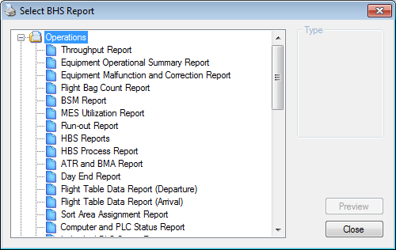

Figure 4‑1: BHS Report Selection Window

The report lists shown on are for example. The actual delivery of the content will be deployed according to Will Rogers World Airport BHS report requirement.

The various areas on the Report Selection Window are described in table below.

| **Item** | **Name** | **Purpose/Function** |
| --- | --- | --- |
|  | Report List | Provide a list of available reports for the users to select and generate. All reports in the list can be generated from the workstation, MDSOWS and SACOWS. |
|
|  | Report Type Option | Some reports are categorized into details and summary.  Users can select either 1) Details or 2) Summary |
|  | Preview Button | Allow users to generate the selected report with the chosen report type (if available). This button will be enable if a report is selected in the Report List and disable when no report is selected in the Report List. |
|
|  | Close Button | Close the Report Selection Window. All opened Report Viewer will also be closed. |

## Report Preview Window

When a report is selected and generated, the following report preview window will pop up.

 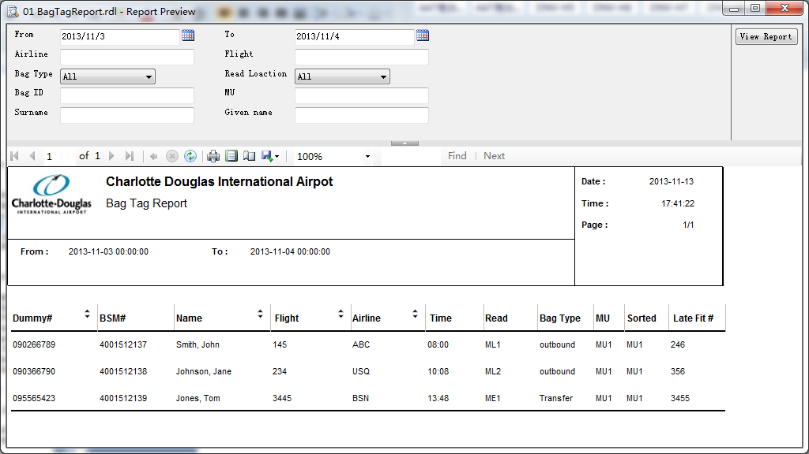

Figure 4‑2: Report Preview Window

The designed areas on the Report Preview Window are as described in the table below.

|  |  |  |
| --- | --- | --- |
| **Item** | **Name** | **Purpose/Function** |
|  | Title bar | (1) Indicates the name of the current report opened in the Report Viewer.  (2) Allows the users to drag the Report Viewer to different location around and within the screen.  (3) Allow the users to close the Report Viewer by clicking on the **X** button. |
|  | Parameter Entry Area | Allow users to specify and change all the required parameters before generating the report with the desired parameters. |
|
|
|  | Toolbar | Contains all the function buttons to perform specific function either on the generated report or on the Report Viewer environment. |
|  | Content Area | It displays the generated reports content and report information. |

The report parameters can be changed and the new result of report can be updated within the Preview window.

The Report Viewer will open with the selected report generated in the report content area if all the parameters for that report are supplied (refer to above). It varies from report to report, some reports are supplied with default value for all parameters and some are not.

The functions for the reports and Report Viewer environment are all hosted as respective function button hosted on the toolbar of the Report Viewer as shown in the figure below.



Figure 4‑3: Report Preview Window Toolbar

The function buttons and their associated function(s) are as described in table below.

| **Item** | **Name** | **Purpose/Function** |
| --- | --- | --- |
|  | Show/Hide Document Map Button | Allow users to show or hide the document map of the report. This function button is a toggle button. It is disabled at all time as it will not be used in this Report application. |
|  | Show/Hide Parameter Area Button | Allow users to show or hide the parameter area. |
|  | Navigation Bar | Allow users to navigate through the report pages for those reports that have more than one page. |
|  | Back to Parent Report Button | Allow users to return to its parent report from the drilled in report. This button will be disabled at all time as there is no drill in reports in this report application. |
|  | Stop Rendering Button | Allow users to stop (cancel) the rendering of a report. |
|  | Refresh Button | Allow users to refresh the report. |
|  | Print Button | Allow users to pop up the standard print dialogue box for selecting printer and configuring the printing settings for the report. |
|  | Print Layout Button | Allow users to switch between normal view and print layout view. This function button is a toggle button. |
|  | Page Setup Button | Allow users to setup the page for the report. |
|  | Export Button | Allow users to export the report in the following available file format:  •         Acrobat (PDF) file  •         Word  •         Excel |
|  | Zoom Selection Dropdown List | Allow users to zoom in or zoom out the entire report. Available options are:  •         Page Width  •         Whole Page  •         500%  •         200%  •         150%  •         100%  •         75%  •         50%  •         25% |
|  | Search Bar | Allow the users to search by specified the word entered in the text box of the search Bar. |

## Report Preview Display Layout

The Report Preview window provides two different layouts for viewing the report, namely the Normal view, and the Print Layout view.

The report will always be displayed in the normal view whenever it is selected and then generated via the Preview button on the Report Selection Window. The generated report can then be switched between the Normal View and the Print Layout View by clicking on the Print Layout toggle button ().

In the above, it is a generated report viewed in the Normal view, whereas the below shows the generated report viewed in Print Layout View.

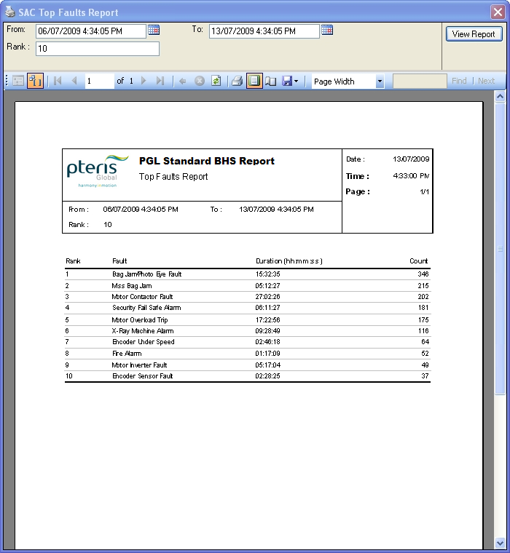

Figure 4‑4: Report in Print Window Toolbar

# BHS REPORT DESIGN AND SAMPLES

## Tag Report

**General Information:**

|  |  |
| --- | --- |
| **Report Title** | Tag Report |
| **Purpose** | Printout of all tag numbers during the operational period. |

**Report Boundaries:**

|  |  |  |
| --- | --- | --- |
| **No.** | **Parameter Name** | **Description** |
| 1 | SDO | The flight schedule departure date. |

**Report Fields:**

|  |  |  |  |
| --- | --- | --- | --- |
| **No.** | **Fields Name** | **Data Type** | **Description** |
| 1 | Dummy# | Text | Pseudo ID# for tracking bags with PLC. |
| 2 | BSM# | Text | The IATA license plate. |
| 3 | Name | Text | The passenger name. |
| 4 | Airline | Text | The airline for which the baggage belongs to. |
| 5 | Flight # | Text | The flight number of the baggage belongs to. |
| 6 | Time | Date Time | When ATR read the tag. |
| 7 | Read | Text | Where ATR read the tag. |
| 8 | Bag Type | Text | Passenger bag type. |
| 9 | MU | Text | The Make-up device that the bag assigned to. |
| 10 | Sorted | Text | The Make-up device that the bag sorted to. |
| 11 | Late Flt # | Text | Secondary flight if bag misses first flight. |

**Report Sample:**

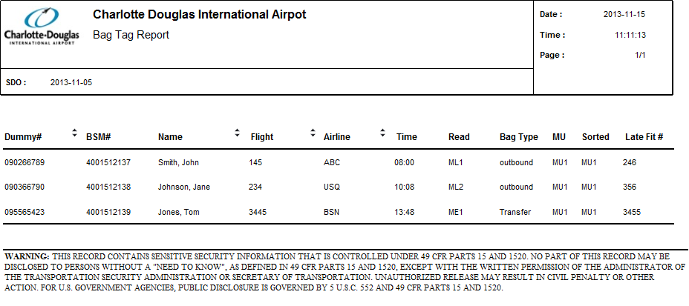

Figure 5‑1: Tag Report Sample

## EDS ID Report

**General Information:**

|  |  |
| --- | --- |
| **Report Title** | EDS ID Report |
| **Purpose** | Printout of all GID during the operational period. |

**Report Boundaries:**

|  |  |  |
| --- | --- | --- |
| **No.** | **Parameter Name** | **Description** |
| 1 | Date | The date when bag screened by EDS machine. |

**Report Fields:**

|  |  |  |  |
| --- | --- | --- | --- |
| **No.** | **Fields Name** | **Data Type** | **Description** |
| 1 | ID# | Text | Baggage GID. |
| 2 | Time Assigned | Date Time | The time at which the bag GID was assigned by the EDS machine. |
| 3 | Screened By | Text | The EDS machine ID. |
| 4 | Time Screened | Date Time | The time when the bag is screened by EDS machine. |
| 5 | Time Cleared | Date Time | The time when the bag is screened as “Pass” from EDS machine. |
| 6 | Time Delivered to CBRA | Date Time | The time when the bag is delivered to CBRA. |
| 7 | Time Removed at CBRA | Date Time | The time when the bag is removed at CBRA. |
| 8 | Bag Type | Text | The Bag type. |

**Report Sample:**

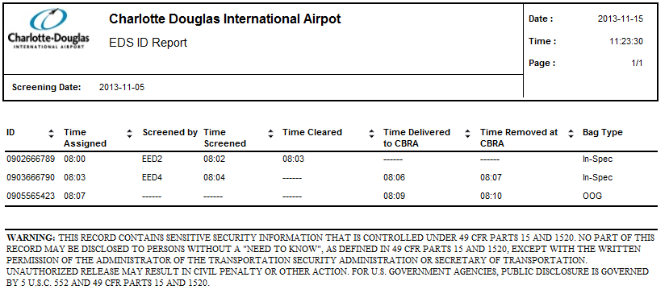

Figure 5‑2: EDS ID Report Sample

## Standby Baggage Report

**General Information:**

|  |  |
| --- | --- |
| **Report Title** | Standby Baggage Report |
| **Purpose** | Printout of all standby baggage during the operational period. |

**Report Boundaries:**

|  |  |  |
| --- | --- | --- |
| **No.** | **Parameter Name** | **Description** |
| 1 | From | The duration from which the data will be retrieved for the report. |
| 2 | To | The duration to which the data will be retrieved for the report. |

**Report Fields:**

|  |  |  |  |
| --- | --- | --- | --- |
| **No.** | **Fields Name** | **Data Type** | **Description** |
| 1 | Date | Date Time | The standby passenger checked in date. |
| 2 | Name | Text | The standby passenger name. |
| 3 | TAG# | Text | The baggage license plate. |
| 4 | Flight# | Text | The standby passenger flight. |
| 5 | Airline | Text | The airline for which the flight belongs to. |
| 6 | Time | Text | The standby passenger checked in time. |
| 7 | Read | Text | The name of ATR where the baggage is read. |
| 8 | Assigned MU | Text | The Make-up device that the bag assigned to. |
| 9 | MU Sorted | Text | The Make-up device that the bag sorted to. |

**Report Sample:**

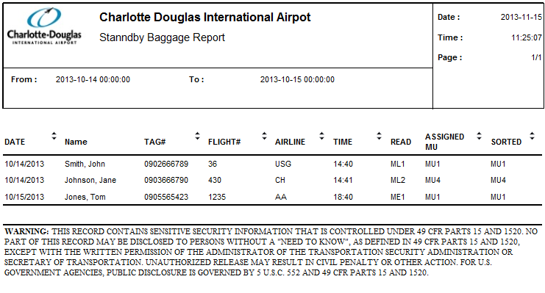

Figure 5‑3: Standby Baggage Report Sample

## Sort Correlation Table

**General Information:**

|  |  |
| --- | --- |
| **Report Title** | Sort Correlation Table |
| **Purpose** | Printout of the entire Flight Record database. |

**Report Boundaries:**

|  |  |  |
| --- | --- | --- |
| **No.** | **Parameter Name** | **Description** |
| 1 | SDO | The flight schedule departure date. |
| 2 | Airline | The Airline to be included in the report. This parameter can have multiple values. |

**Report Fields 1 (The Fight List):**

|  |  |  |  |
| --- | --- | --- | --- |
| **No.** | **Fields Name** | **Data Type** | **Description** |
| 1 | Airline | Text | The airline for which the baggage belongs to. |
| 2 | Flight# | Text | The flight number of the baggage belongs to. |
| 3 | Destination | Text | The flight destination. |
| 4 | Close-out Time | Date Time | The flight close time. |
| 5 | Departure Time | Date Time | The flight departure time. |
| 6 | MU | Text | The Make-up device assigned by FIS. |
| 7 | Default MU | Text | The Make-up device assigned by DA. |
| 8 | DAYS | Numeric | The flight operation days. |

**Report Fields 2 (The Fight Functional Allocation):**

|  |  |  |  |
| --- | --- | --- | --- |
| **No.** | **Fields Name** | **Data Type** | **Description** |
| 1 | Primary | Text | The Make-up device for standard sort destination flight assignment. |
| 2 | First | Text | The Make-up device for first class passenger bags. |
| 3 | Business | Text | The Make-up device for business class passenger bags. |
| 4 | Hot | Text | The Make-up device for bags that will arrive prior to a flight’s departure but after the flight closed out. |
| 5 | Late | Text | The Make-up device for bags that will arrive after a flight’s departure. |
| 6 | Standby | Text | The Make-up device for standby passenger bags. |

**Report Sample:**

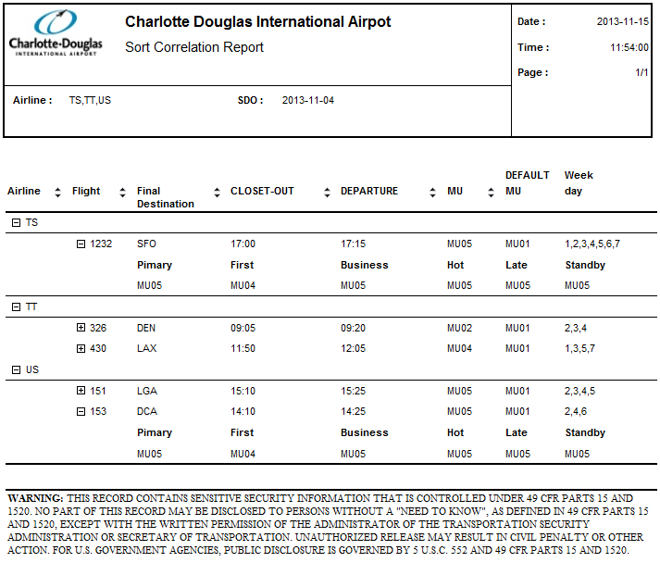 Figure 5‑4: Sort Correlation Report Sample

## Immediate Equipment Malfunction and Correction Report

### Upon Detection of Equipment

**General Information:**

|  |  |
| --- | --- |
| **Report Title** | Immediate Equipment Malfunction and Correction Report |
| **Purpose** | Automatic printout upon detection of each equipment malfunction. |

**Report Boundaries:**

|  |  |  |
| --- | --- | --- |
| **No.** | **Parameter Name** | **Description** |
| 1 | From | The duration from which the data will be retrieved for the report. |
| 2 | To | The duration to which the data will be retrieved for the report. |
| 3 | Subsystem | The subsystem(s) to be included in the report. This parameter can have multiple values. |
| 4 | Equipment ID | The equipment(s) to be included in the report. This parameter can have multiple values. |
| 5 | Fault Type | The fault type(s) to be included in the report. This parameter can have multiple values. |

**Report Fields:**

|  |  |  |  |
| --- | --- | --- | --- |
| **No.** | **Fields Name** | **Data Type** | **Description** |
| 1 | Subsystem | Text | The subsystem for which the equipment(s) belong to. |
| 2 | Equip. ID | Text | The identification of the equipment. |
| 3 | Malfunction Description | Text | The description of the fault. |
| 4 | Timeset | Date Time | The start time of the fault occurrence. |
| 5 | Fault Count | Numeric | The count of fault occurrence. |

**Report Sample:**

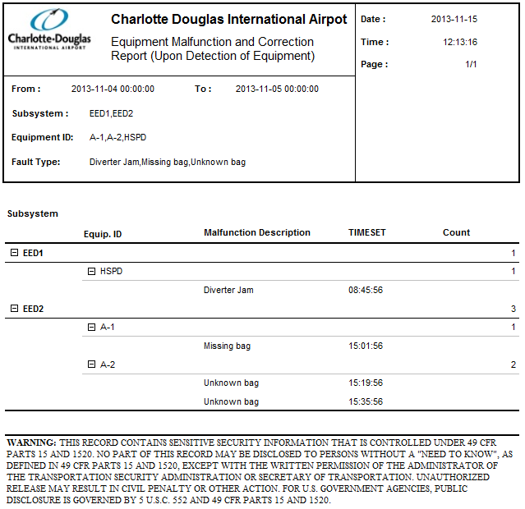

Figure ‑: Equipment Malfunction and Correction Report Sample(Upon Detection of Equipment)

### Upon Correction of Malfunction

**General Information:**

|  |  |
| --- | --- |
| **Report Title** | Immediate Equipment Malfunction and Correction Report |
| **Purpose** | Automatic printout upon detection of each equipment subsequent correction. |

**Report Boundaries:**

|  |  |  |
| --- | --- | --- |
| **No.** | **Parameter Name** | **Description** |
| 1 | From | The duration from which the data will be retrieved for the report. |
| 2 | To | The duration to which the data will be retrieved for the report. |
| 3 | Subsystem | The subsystem(s) to be included in the report. This parameter can have multiple values. |
| 4 | Equipment ID | The equipment(s) to be included in the report. This parameter can have multiple values. |
| 5 | Fault Type | The fault type(s) to be included in the report. This parameter can have multiple values. |

**Report Fields:**

|  |  |  |  |
| --- | --- | --- | --- |
| **No.** | **Fields Name** | **Data Type** | **Description** |
| 1 | Subsystem | Text | The subsystem for which the equipment(s) belong to. |
| 2 | Equip. ID | Text | The identification of the equipment. |
| 3 | Description | Text | The detail description of the fault. |
| 4 | Timeset | Date Time | The start time of the fault occurrence. |
| 5 | Time Clear | Date Time | The time of malfuntion cleared. |
| 6 | Difference | Text | The duration of the fault occurrence specified in hh:mm:ss format.  *Note: HH = hours (24 hours format), mm = minutes, ss = seconds* |

**Report Sample:**

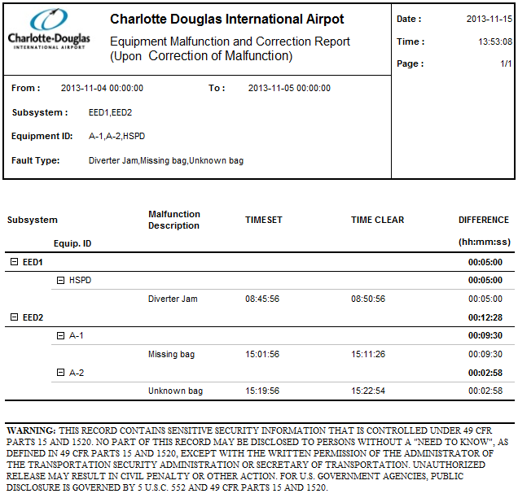

Figure ‑: Equipment Malfunction and Correction Report Sample(Upon Correction of Malfunction)

## Equipment Operational Summary Report

**General Information:**

|  |  |
| --- | --- |
| **Report Title** | Equipment Operational Summary Report |
| **Purpose** | Printout, by subsystem, of diverter, photocell, and sorter statistics and summary of individual device malfunctions printed in Equipment Malfunction and Correction Report. |

**Report Boundaries:**

|  |  |  |
| --- | --- | --- |
| **No.** | **Parameter Name** | **Description** |
| 1 | From | The duration from which the data will be retrieved for the report. |
| 2 | To | The duration to which the data will be retrieved for the report. |
| 3 | Subsystem | The subsystem(s) to be included in the report. This parameter can have multiple values. |

**Report Fields:**

|  |  |  |  |
| --- | --- | --- | --- |
| **No.** | **Fields Name** | **Data Type** | **Description** |
| 1 | Tracking | - | - |
| 1.1 | Photocell ID | Text | The identification of the Photocell . |
| 1.2 | Missing Bags | Numeric | The count of bags missing at photocell. |
| 1.3 | Unknown Bags | Numeric | The count of unknown bags at photocell. |
| 1.4 | JAMS | Numeric | The count of bag jams at photocell. |
| 2 | JAM Photocell | - | - |
| 2.1 | Photocell ID | Text | The identification of the Photocell where bag jams happen. |
| 2.2 | JAMS | Numeric | The count of Jams. |
| 3 | Diverter | - | - |
| 3.1 | Equip. ID | Text | The identification of Diverters. |
| 3.2 | Extended | Numeric | The count of diverter extended position. |
| 3.3 | Home | Numeric | The count of diverter at home position. |

**Report Sample:**

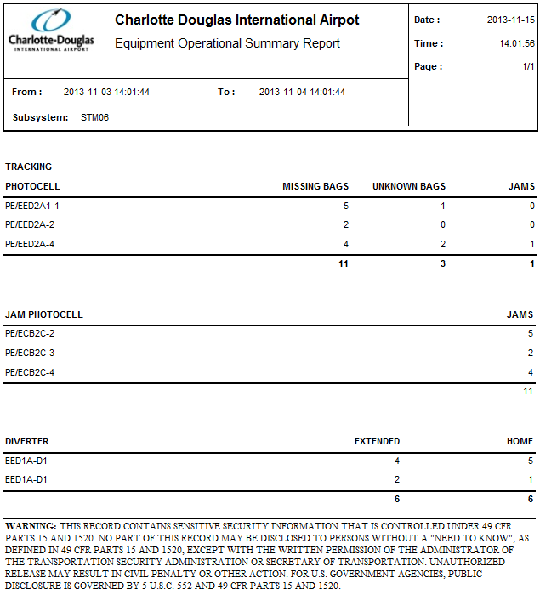

Figure ‑: Equipment Operational Summary Report Sample

## Computer and PLC Status Report

### Computer And PLC Status Report

**General Information:**

|  |  |
| --- | --- |
| **Report Title** | Computer and PLC Status Report |
| **Purpose** | Print out of which computer is on-online/offline and the computer status as well as which PLC is online/offline and the PLC status. |

**Report Boundaries:**

None.

**Report Fields (Computer and PLC Status Report):**

|  |  |  |  |
| --- | --- | --- | --- |
| **No.** | **Fields Name** | **Data Type** | **Description** |
| **1** | **Computer Status** |  |  |
| 1.1 | Computer ID | Text | The identification of computer and workstation. |
| 1.2 | Online/Offline Status | Text | The Online/Offline status of the equipment. |
| 1.3 | Status | Text | The current status of the equipment. |
| **2** | **Sort Controller** |  |  |
| 2.1 | Sort Controller ID | Text | The identification of Sort Controller. |
| 2.2 | Online/Offline Status | Text | The Online/Offline status of the equipment. |
| 2.3 | Status | Text | The current status of the equipment. |
| **3** | **PLC BANK** |  |  |
| 3.1 | PLC Bank ID | Text | The identification of PLC. |
| 3.2 | Online/Offline Status | Text | The Online/Offline status of the equipment. |
| 3.3 | Status | Text | The current status of the equipment. |
| **4** | **UPS Status** |  |  |
| 4.1 | UPS ID |  | The identification of UPS |
| 4.2 | UPS Charge Percentage(%) | Numeric | The remaining power of the UPS. |
| 4.3 | Status | Text | The current status of the UPS. |
| 4.4 | Runtime Remaining | Time | If battery powered, the remaining run time. |

**Report Sample:**

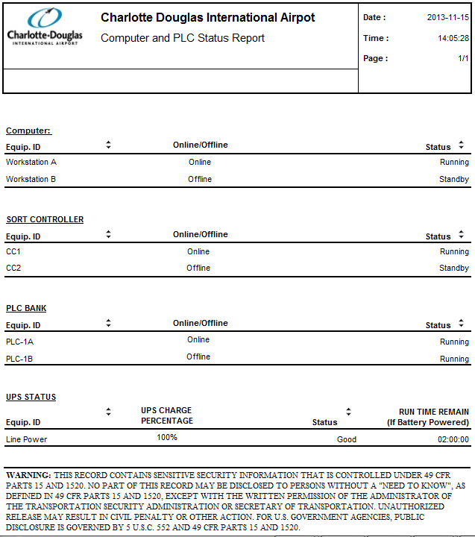

Figure ‑: Computer And PLC Status Report Sample

### Individual PLC Status Report

**General Information:**

|  |  |
| --- | --- |
| **Report Title** | Individual PLC Status Report |
| **Purpose** | Provide the status information for an individual PLC. |

**Report Boundaries:**

|  |  |  |
| --- | --- | --- |
| **No.** | **Parameter Name** | **Description** |
| 1 | PLC ID | The PLC name from which the data will be retrieved for the report. |

**Report Fields (Computer and PLC Status Report):**

|  |  |  |  |
| --- | --- | --- | --- |
| **No.** | **Fields Name** | **Data Type** | **Description** |
| 1 | Report Type |  |  |
| 2 | PLC Name | Text | The name or identification of the selected PLC. |
| 3 | Software Type | Text | The software type of the selected PLC. |
| 4 | Software Revision | Text | The Software revision of the selected PLC. |
|  | | | |
| 5 | PLC Status Registers | - | - |
| 6 | Key position | Text | Run/Program/Remote. |
| 7 | Status | Text | Running/Online/Offline/Fault/Available. |
|  | | | |
| 8 | LED Status | - | - |
| 9 | Processor | Text | The LED Status of PLC processor. |
| 10 | Force | Text | The LED Status of PLC force. |
| 11 | Communication | Text | The LED Status of PLC communication. |
| 12 | Battery Power | Text | The LED Status of PLC battery power. |
|  | | | |
| 13 | Memory Size | Numeric | The memory size of the selected PLC. |
| 14 | Memory Used | Numeric | The memory already used. |
| 15 | Memory Compiled | Numeric | The memory compiled. |
| 16 | Rung Count | Numeric | The rung consumed. |
| 17 | Scan Time | Time | The program scan time. |
|  | | | |
| 18 | Fault Error Code | - | - |
| 19 | Processor Error | Numeric | The count of processor error for the selected PLC. |
| 20 | Network Error | Numeric | The count of network error for the selected PLC. |

**Report Sample:**

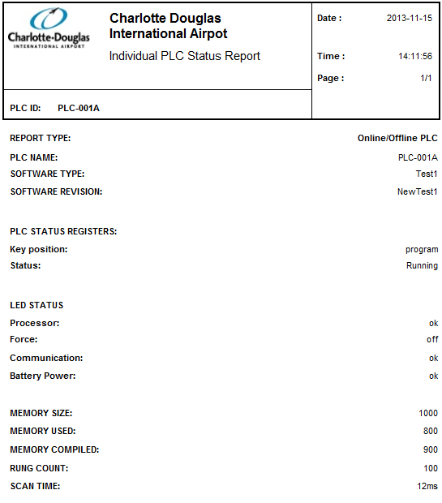

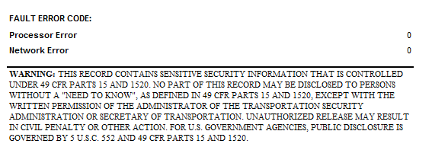

Figure ‑: Individual PLC Status Report Sample

## Equipment Malfunction Summary Report

**General Information:**

|  |  |
| --- | --- |
| **Report Title** | Equipment Malfunction Summary Report |
| **Purpose** | Printout, by subsystem, of a summary of the Equipment malfunction and Correction Reports. |

**Report Boundaries:**

|  |  |  |
| --- | --- | --- |
| **No.** | **Parameter Name** | **Description** |
| 1 | From | The duration from which the data will be retrieved for the report. |
| 2 | To | The duration to which the data will be retrieved for the report. |
| 3 | Fault Type | The fault type(s) to be included in the report. This parameter can have multiple values.    Designated fault can be selected by the operator and include in the calculation of the report. |

**Report Fields:**

|  |  |  |  |
| --- | --- | --- | --- |
| **No.** | **Fields Name** | **Data Type** | **Description** |
| 1 | Equipment Fault Type | Text | The fault type(s) to be included in the report. |
| 2 | Occurrences | Numeric | The total count of fault occurrences. |
| 3 | Fault Duration | Text | The duration of the fault occurrence specified in hh:mm:ss format.  *Note: HH = hours (24 hours format), mm = minutes, ss = seconds* |

**Report Sample:**

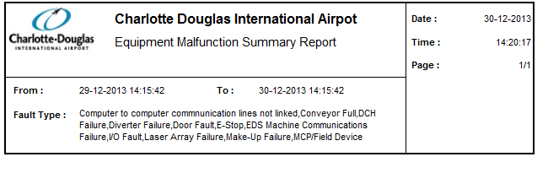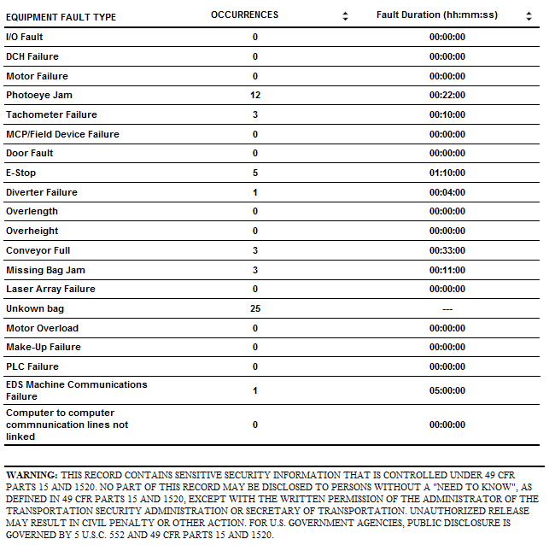

Figure ‑: Equipment Malfunction Summary Report Sample

## MEC Report

**General Information:**

|  |  |
| --- | --- |
| **Report Title** | MEC Report |
| **Purpose** | Printout of Individual Manual encoding station statistics for different reasons. |

**Report Boundaries:**

|  |  |  |
| --- | --- | --- |
| **No.** | **Parameter Name** | **Description** |
| 1 | From | The duration from which the data will be retrieved for the report. |
| 2 | To | The duration to which the data will be retrieved for the report. |

**Report Fields ( “Dispatched By” shown in rows):**

|  |  |  |  |
| --- | --- | --- | --- |
| **No.** | **Fields Name** | **Data Type** | **Description** |
| 1 | FLIGHT | Numeric | The count of dispatched bags by flight |
| 2 | SCANNING | Numeric | The count of dispatched bags by hand held scanning. |
| 3 | DESTINATION | Numeric | The count of dispatched bags by airline code. |
| 4 | PIER/MAKE-UP/CHUTE | Numeric | The count of dispatched bags by destination. |
| 5 | BSM | Numeric | The count of dispatched bags by license plate. |
| 6 | RUNOUT | Numeric | The count of dispatched bags which cannot be automatically sorted due to a distinguishable pier, flight information available. |
| 7 | PROBLEM STATION | Numeric | The count of dispatched bags by problem bag. |
| 8 | LATE BSMS | Numeric | The count of dispatched bags by no BSM info. |
| 9 | TOTAL BAGS | Numeric | The total count of dispatched bags . |

**Report Sample:**

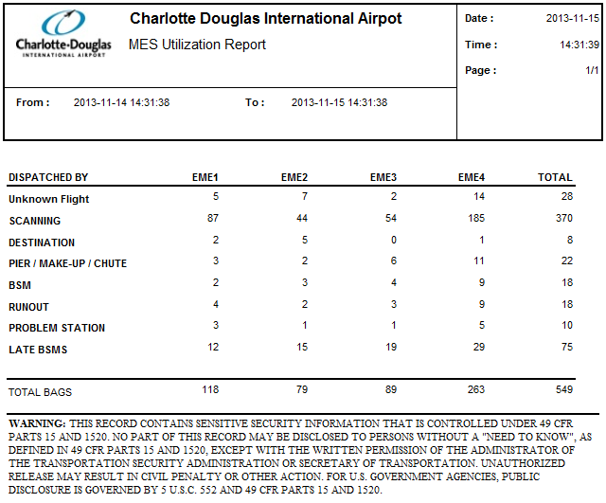

Figure ‑: MEC Report Sample

## Load Balancing Report

**General Information:**

|  |  |
| --- | --- |
| **Report Title** | Load Balancing Report |
| **Purpose** | Provides individual subsystem loading for the operational period. |

**Report Boundaries:**

|  |  |  |
| --- | --- | --- |
| **No.** | **Parameter Name** | **Description** |
| 1 | From | The duration from which the data will be retrieved for the report. |
| 2 | To | The duration to which the data will be retrieved for the report. |
| 3 | Interval | The distribution interval in term of minutes to be used.  Interval value: 1 Minute to 1440 Minutes. |
| 4 | Subsystem | The subsystem to be included in the report. This parameter can have multiple values. |

**Report Fields:**

|  |  |  |  |
| --- | --- | --- | --- |
| **No.** | **Fields Name** | **Data Type** | **Description** |
| 1 | EQUIPMENT type | Text | The type of equipment. |
| 2 | Subsystem ID | Text | The name of subsystem. |
| 3 | Total bags | Numeric | The count of total bags during the selected duration. |
| 4 | current interval load | Numeric | The count of bags of selected interval. |
| 5 | EDS Load | - | - |
| 5.1 | EDS Equipment type | Text | The equipment type of EDS. |
| 5.2 | EDS ID | Text | The name of EDS equipment. |
| 5.3 | Number of Bags | Numeric | The number of baggages go through EDS device. |
| 5.4 | Number of Cleared | Numeric | The number of cleared bag. |
| 5.5 | Number Alarmed | Numeric | The number of alarmed bag. |
| 5.6 | Percentage | Numeric | The percentage of cleared bags out of total bags. |

**Report Sample:**

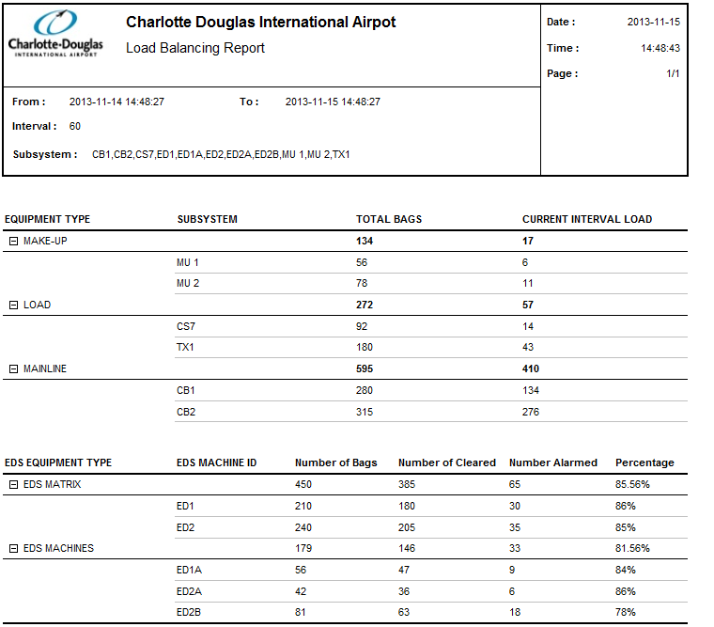

Figure ‑: Load Balancing Report Sample

## Runout Report

**General Information:**

|  |  |
| --- | --- |
| **Report Title** | Run-out Report |
| **Purpose** | Printout of the reason of the bag sorted to default pier/make-up unit statistics for each subsystem. Time interval for current throughput figures is selectable from 1 minute to 24 hours. |

**Report Boundaries:**

|  |  |  |
| --- | --- | --- |
| **No.** | **Parameter Name** | **Description** |
| 1 | From | The duration from which the data will be retrieved for the report. |
| 2 | To | The duration to which the data will be retrieved for the report. |
| 3 | Interval | The distribution interval in term of minutes to be used.  Interval value: 1 Minute to 24hours. |
| 4 | Make-up unit | The make-up carousel to be included in the report. |

**Report Fields:**

|  |  |  |  |
| --- | --- | --- | --- |
| **No.** | **Fields Name** | **Data Type** | **Description** |
| 1 | SUBSYSTEM | Text | The runout subsystem. |
| 2 | Time | Time | The time when runout happened.  Format: hh:mm |
| 3 | BSM# | Text | The bag license plate. |
| 4 | EQUIPMENT ID | Text | The runout equipment ID. |
| 5 | REASON | Text | The runout reason. |

**Report Sample:**

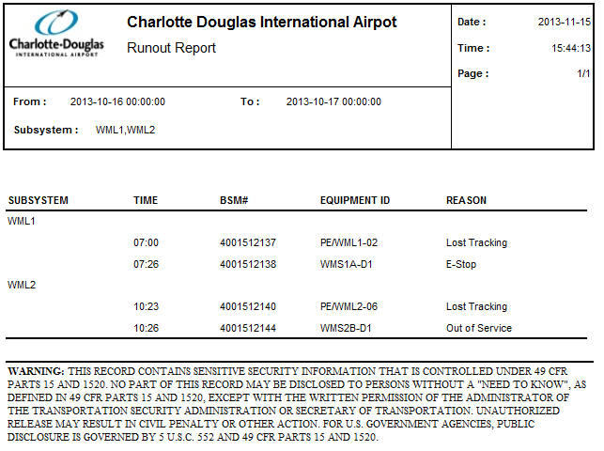

Figure ‑: Runout Report Sample

## Automatic Tag Reader (ATR) Report

**General Information:**

|  |  |
| --- | --- |
| **Report Title** | ATR Report |
| **Purpose** | Printout of all laser array head statistics. |

**Report Boundaries:**

|  |  |  |
| --- | --- | --- |
| **No.** | **Parameter Name** | **Description** |
| 1 | From | The duration from which the data will be retrieved for the report. |
| 2 | To | The duration to which the data will be retrieved for the report. |
| 3 | ATR Unit | The ATR unit which the data will be retrieved for the report. |

**Report Fields 1 (statistics information for each head):**

|  |  |  |  |
| --- | --- | --- | --- |
| **No.** | **Fields Name** | **Data Type** | **Description** |
| 1 | ATR NUMBER | Text | The name of the ATR unit. |
| 2 | BAGS READ | Numeric | The count of bags read by each head. |
| 3 | % READ of TOTAL | Numeric | The percentage of bags read by each head. |

**Report Fields 2 (overall statistics information for the above ATR):**

|  |  |  |  |
| --- | --- | --- | --- |
| No. | Fields Name | Data Type | Description |
| 1 | BAGS SEEN | Numeric | The total count of bag seen by ATR. |
| 2 | BAGS READ | Numeric | The total good read bag count by ATR. |
| 3 | NO READS | Numeric | The total no read bag count by ATR. |
| 4 | VALID TAGS | Numeric | The total valid tags read by ATR. |
| 5 | CONFLICT TAGS | Numeric | The conflict tags read by ATR. |
| 6 | NO MATCHING BSM | Numeric | The tags without matching BSM information. |
| 7 | Read Rate (%) | Numeric | The ATR read rate. |

**Report Sample:**

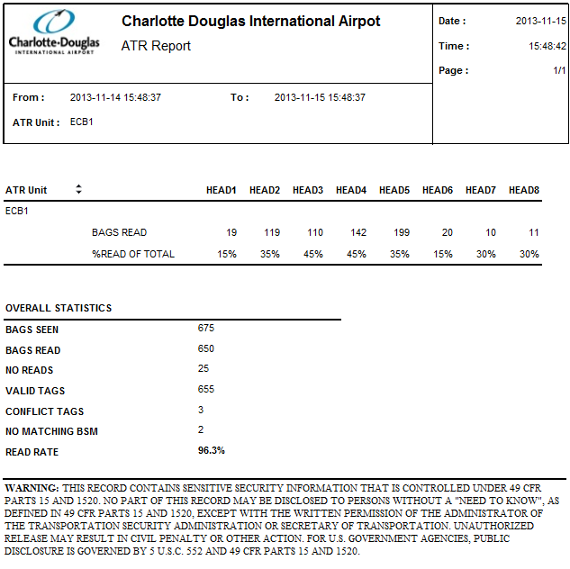

Figure ‑: Automatic Tag Reader (ATR) Report Sample

## EDS Report

### EDS MACHINE STATUS REPORT

**General Information:**

|  |  |
| --- | --- |
| **Report Title** | EDS Machine Status Report |
| **Purpose** | Print out of which EDS machine (by EDS Serial Number and EDS Conveyor ID) is on-line/offline and the machine status. |

**Report Boundaries:**

None

**Report Fields (EDS MACHINE STATUS REPORT):**

|  |  |  |  |
| --- | --- | --- | --- |
| **No.** | **Fields Name** | **Data Type** | **Description** |
| 1 | EDS MACHINE | Text | The name of EDS machine. |
| 2 | COMMUNICATION SIGNAL | Text | The EDS machine communication signal. |
|  | | | |
| 3 | PLC BANK | Text | The PLC bank used by EDS machine. |
| 4 | Online Status | Text | The PLC bank Online/offline status. |
| 5 | STATUS | Text | The PLC bank working status. |
|  | | | |
| 6 | COMMUNICATION INTERFACE MODULE | Text | The identification of communication interface module |
| 7 | STATUS | Text | The communicating status of communication interface module |

**Report Sample:**

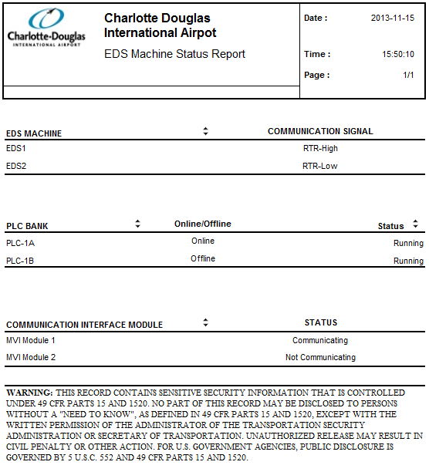

Figure ‑: EDS Machine Status Report Sample

### INDIVIDUAL EDS MACHINE STATUS REPORT

**General Information:**

|  |  |
| --- | --- |
| **Report Title** | INDIVIDUAL EDS MACHINE STATUS REPORT |
| **Purpose** | Print out Individual EDS machine status. |

**Report Boundaries:**

|  |  |  |
| --- | --- | --- |
| **No.** | **Parameter Name** | **Description** |
| 1 | From | The duration from which the data will be retrieved for the report. |
| 2 | To | The duration to which the data will be retrieved for the report. |
| 3 | EDS ID | To specify EDS machine about which the status data will be shown |

**Report Fields (INDIVIDUAL EDS MACHINE STATUS REPORT):**

|  |  |  |  |
| --- | --- | --- | --- |
| **No.** | **Fields Name** | **Data Type** | **Description** |
| 1 | EDS NAME | Text | The identification of EDS machine. |
| 2 | SOFTWARE TYPE | Text | The software type of the selected EDS machine |
| 3 | SOFTWARE REVISION | Text | The software revision of the selected EDS machine |
|  | | | |
| 4 | EDS STATUS REGISTERS | - | - |
| 5 | Run position | Text | EDS machine run position. |
| 6 | Status | Text | The working status of the selected EDS. (Running/Online/Offline/Fault/Available/E-Stop/Warm-up). |
| 7 | PLC Scan Time | Text | The EDS machine PLC scan time. |
|  | | | |
| 8 | EDS AVAILABILITY AND COUNTS | - | - |
| 9 | E-Stop | Text | The total duration of E-stop. |
| 10 | Faults | Text | The total duration of Faults. |
| 11 | RTR High | Text | The total duration of RTR-High. |
| 12 | RTR Low | Text | The total duration of RTR-Low. |
| 13 | Jams | Numeric | The count of jams. |
|  | | | |
| 14 | Total Bags Screened | Numeric | The total count of bags screened. |
| 15 | Total Clear Bags | Numeric | The total count of bags cleared. |
| 16 | Total Alarmed Bags | Numeric | The total count of bags alarmed. |
| 17 | Total EDS Unkown Bags | Numeric | The total count of EDS unknown bags. |
| 18 | Total In Tracking Bags | Numeric | The total count of tracking bags. |
| 19 | Total BHS Unkown Bags | Numeric | The total count of BHS unknown bags. |
| 20 | Percentage BHS Unkown Bags (%) | Numeric | The percentage of BHS unknown bags. |
| 21 | EDS Decision Timeouts | Numeric | The total count of timeout. |
| 22 | Average Level 2 Decision Time | Text | The average Level 2 decision time. |
| 23 | Average Bag Processing Time | Text | The average bag processing time. |

**Report Sample:**

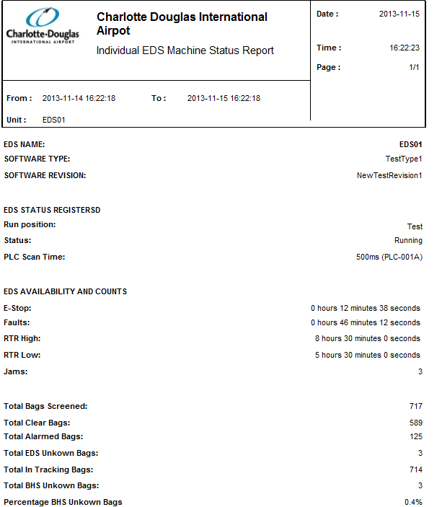

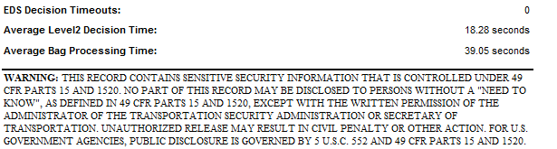

Figure ‑: Individual EDS Machine Status Report Sample

## Day End Report

**General Information:**

|  |  |
| --- | --- |
| **Report Title** | Day End Report |
| **Purpose** | Printout of throughputs, laser stats, manual encoding stats and outputs. |

**Report Boundaries:**

|  |  |  |
| --- | --- | --- |
| **No.** | **Parameter Name** | **Description** |
| 1 | From | The duration from which the data will be retrieved for the report. |
| 2 | To | The duration to which the data will be retrieved for the report. |

**Report Fields:**

|  |  |  |  |
| --- | --- | --- | --- |
| **No.** | **Fields Name** | **Data Type** | **Description** |
| **1** | **THROUGHPUT** | **-** | **-** |
| 1.1 | INPUT | Text | The location of the input load point. |
| 1.2 | BAGS | Numeric | The total bag counts loaded in input load point. |
| **2** | **ATR LASER STATS** | **-** | **-** |
| 2.1 | ARRAY | Text | The name or id of ATR array. |
| 2.2 | BAGS READ | Numeric | The total count of bag read by each ATR. |
| 2.3 | LATE BAGS | Numeric | The total count of late bags |
| 2.4 | BAGS SEEN | Numeric | The total count of bag seen by each ATR. |
| 2.5 | READ RATE% | Numeric | The percentage of bag read out of bags seen by each ATR. |
| **3** | **BDD STATS** | **-** | **-** |
| 3.1 | ARRAY | Text | The name of BDD array |
| 3.2 | BAGS READ | Numeric | The total count of bag read by each BDD array. |
| 3.3 | BAGS DIMENSIONED | Numeric | The total count of bag dimensioned by each BDD array. |
| 3.4 | DIMENSION RATE% | Numeric | The percentage of bag read out of bags dimensioned by each BDD. |
| **4** | **MANUAL ENCODE STATS** | **-** | **-** |
| 4.1 | STATION | Text | The location for MES. |
| 4.2 | BAGS | Numeric | The total count of bags scanned by each MES. |
| **5** | **EDS MACHINE SECURITY SYSTEM STATS** | **-** | **-** |
| 5.1 | MACHINE | Text | The name of EDS machine |
| 5.2 | BAGS | Numeric | The total count of bags checked by EDS machine |
| 5.3 | BAGS CLEARED | Numeric | The count of bags cleared by EDS. |
| 5.4 | BAGS ALARMED | Numeric | The count of bags alarmed by EDS. |
| 5.5 | PERCENTAGE CLEARED | Numeric | The percentage of bags cleared out of total bags checked by EDS |
| **6** | **OUTPUTS** | **-** | **-** |
| 6.1 | CHUTE/PIER/MAKE-UP UNIT | Text | The location for the output location for make-up carousel. |
| 6.2 | BAGS | Numeric | The total bag count for the output location for make-up carousel. |
| **7** | **TRACKING** | **-** | **-** |
| 7.1 | LINE | Text | The identification of the equipment location. |
| 7.2 | NUMBER OF BAGS | Numeric | The total number of bag count (successful tracked bags and lost tracked bags) on each location. |
| 7.3 | NUMBER LOST TRACKING | Numeric | The number of bag count for unsuccessful or lost tracked baggage. |
| 7.4 | TRACKING PERCENTAGE(MIN 99%) | Numeric | The tracking successful percentage |

**Report Sample:**

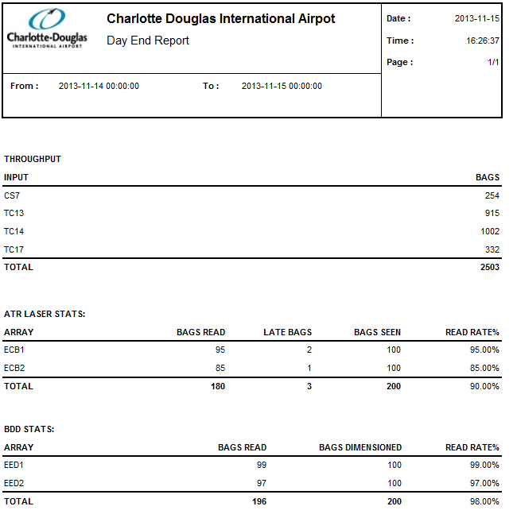

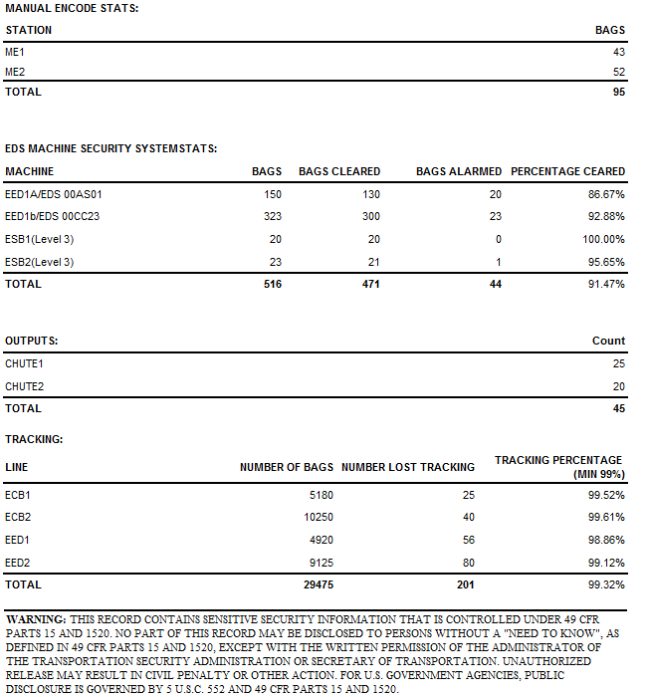

Figure ‑: Day End Report Sample

## Sort Area Assignment Report

**General Information:**

|  |  |
| --- | --- |
| **Report Title** | Sort Area Assignment Report |
| **Purpose** | Printout of system operational summary. |

**Report Boundaries:**

|  |  |  |
| --- | --- | --- |
| **No.** | **Parameter Name** | **Description** |
| 1 | From | The duration from which the data will be retrieved for the report. |
| 2 | To | The duration to which the data will be retrieved for the report. |

**Report Fields:**

|  |  |  |  |
| --- | --- | --- | --- |
| **No.** | **Fields Name** | **Data Type** | **Description** |
| 1 | PHYSICAL MAKE-UP | Text | The name of physical make-up device |
| 2 | ASSIGNED TO | Text | The name of make-up device to which the physical make-up device is assigned.  Labeled if it is reassigned |

**Report Sample:**

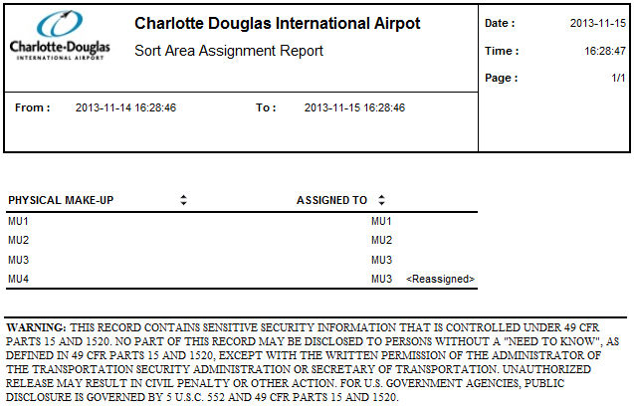

Figure ‑: Sort Area Assignment Report Sample

## Flight Summary Report

**General Information:**

|  |  |
| --- | --- |
| **Report Title** | Flight Summary Report |
| **Purpose** | Printout of Flight Summary Report as reported by the scanner array. |

**Report Boundaries:**

|  |  |  |
| --- | --- | --- |
| **No.** | **Parameter Name** | **Description** |
| 1 | From | The duration from which the data will be retrieved for the report. |
| 2 | To | The duration to which the data will be retrieved for the report. |

**Report Fields:**

|  |  |  |  |
| --- | --- | --- | --- |
| **No.** | **Fields Name** | **Data Type** | **Description** |
| 1 | FLIGHT NUMBER | Text | The flight number of the baggage belongs to. |
| 2 | AIRLINE | Text | The airline for which the baggage belongs to. |
| 3 | NUMBER OF BAGS | Numeric | The total count of bags belonging to the flight. |
| 4 | BAG TYPE | Text | The bag type.  O= Origination, X=Transfer, T=Terminating. |
| 5 | BAGS ON TIME | Numeric | The count of bags sorted on time |
| 6 | BAGS LATE | Numeric | The count of bag sorted late |

**Report Sample:**

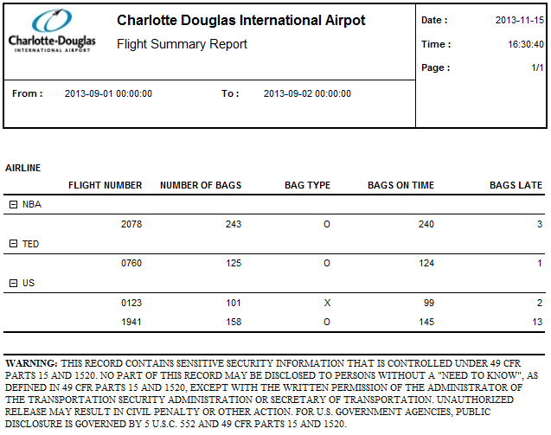

Figure ‑: Flight Summary Report Sample

## Individual Flight Summary Report

**General Information:**

|  |  |
| --- | --- |
| **Report Title** | Individual Flight Summary Report |
| **Purpose** | Provides information of the individual flight summary report as reported by the sort pier. |

**Report Boundaries:**

|  |  |  |
| --- | --- | --- |
| **No.** | **Parameter Name** | **Description** |
| 1 | From | The duration from which the data will be retrieved for the report. |
| 2 | To | The duration to which the data will be retrieved for the report. |
| 3 | Airline | The Airline to be included in the report. This parameter can have multiple values. |
| 4 | Flight Number | The Flight Number to be included in the report. This parameter can have multiple values. |

**Report Fields 1 (Flight information):**

|  |  |  |  |
| --- | --- | --- | --- |
| **No.** | **Fields Name** | **Data Type** | **Description** |
| 1 | FLIGHT# | Text | The flight number of the baggage belongs to. |
| 2 | Airline | Text | The airline for which the baggage belongs to. |
| 3 | CLOSE OUT TIME | Text | The flight close out time |
| 4 | NUMBER OF BAGS SORTED | Numeric | The number of bags sorted by BHS |
| 5 | BAGS ON TIME | Numeric | The count of bags sorted on time |
| 6 | BAGS STILL IN SYSTEM | Numeric | The count of bags still in system |
| 7 | BAGS LATE | Numeric | The count of bags sorted late |

**Report Fields 2 (BAG DETAILS):**

|  |  |  |  |
| --- | --- | --- | --- |
| **No.** | **Fields Name** | **Data Type** | **Description** |
| 1 | BSM# | Text | The make-up carousel of the allocation. |
| 2 | PAX NAME | Text | The passenger name |
| 3 | TIME BSM RECEIVED | Text | The time of BSM received. (hh:mm:ss) |
| 4 | TIME READ ATR | Text | The time of bag tag read by ATR. (hh:mm:ss) |
| 5 | TIME SORTED | Text | The time of bag sorted by BHS. (hh:mm:ss) |

**Report Sample:**

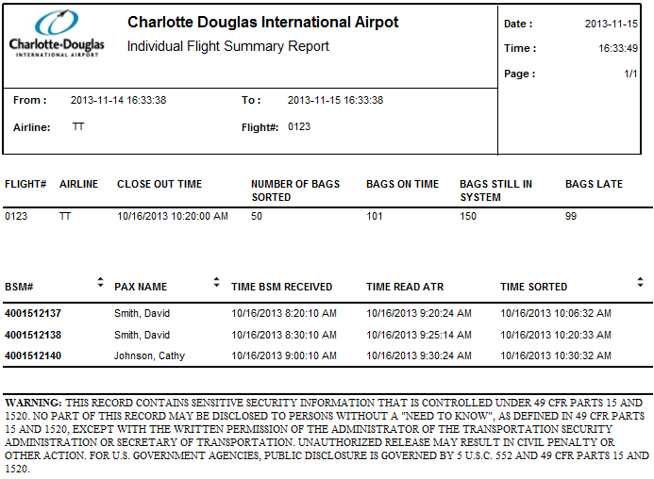

Figure ‑: Individual Flight Summary Report Sample

## Bag Tag Not Found Report

**General Information:**

|  |  |
| --- | --- |
| **Report Title** | Bag Tag Not Found Report |
| **Purpose** | Provides all the bag tags read with no destination details. |

**Report Boundaries:**

|  |  |  |
| --- | --- | --- |
| **No.** | **Parameter Name** | **Description** |
| 1 | From | The duration from which the data will be retrieved for the report. |
| 2 | To | The duration to which the data will be retrieved for the report. |

**Report Fields:**

|  |  |  |  |
| --- | --- | --- | --- |
| **No.** | **Fields Name** | **Data Type** | **Description** |
| 1 | CARRIER ID | Text | The carrier ID. |
| 2 | TAG NUMBER  NOT FOUND | Text | The tag number of the baggage without destination. |
| 3 | TIME SEEN | Text | The timestamp when the baggage is scanned. (hh:mm) |
| 4 | LOCATION SEEN | Text | The device where the bag tag is scanned. |
| 5 | PAX NAME | Text | The passenger name. |
| 6 | FLT# | Text | The airline and flight number of the baggage belongs to. |

**Report Sample:**

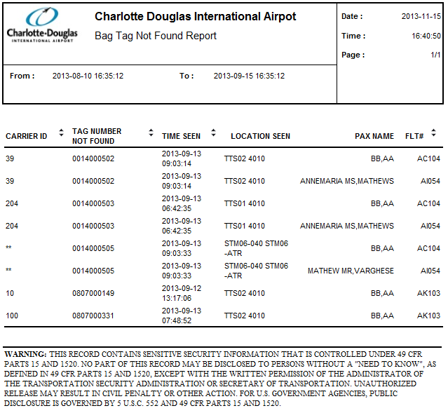

Figure ‑: Bag Tag Not Found Report Sample

## BSM Report

**General Information:**

|  |  |
| --- | --- |
| **Report Title** | BSM Report |
| **Purpose** | Printout of all tag numbers during the operational period. |

**Report Boundaries:**

|  |  |  |
| --- | --- | --- |
| **No.** | **Parameter Name** | **Description** |
| 1 | From | The duration from which the data will be retrieved for the report. |
| 2 | To | The duration to which the data will be retrieved for the report. |
| 3 | Airline | The Airline to be included in the report. This parameter can have multiple values. |
| 4 | Flight Number | The Flight Number to be included in the report. This parameter can have multiple values. |

**Report Fields:**

|  |  |  |  |
| --- | --- | --- | --- |
| **No.** | **Fields Name** | **Data Type** | **Description** |
| 1 | TAG# | Text | The baggage license plate. |
| 2 | NAME | Text | The passenger name. |
| 3 | FLIGHT# | Text | The flight number. |
| 4 | AIRLINE | Text | The airline. |
| 5 | TIME | Text | The time when the bag was read. |
| 6 | READ | Text | The location of ATR where the bag was read before arriving to a pier destination or MES. |
| 7 | BAG TYPE | Text | The bag type (outbound, transfer…..) |
| 8 | BSM REC’D | Text | Indicating the time when BSM was received at the BHS from the Host. |
| 9 | PRINT | Text | The time the bag tag was printed. |
| 10 | LATE | Text | Indicates whether this is a late bag. |

**Report Sample:**

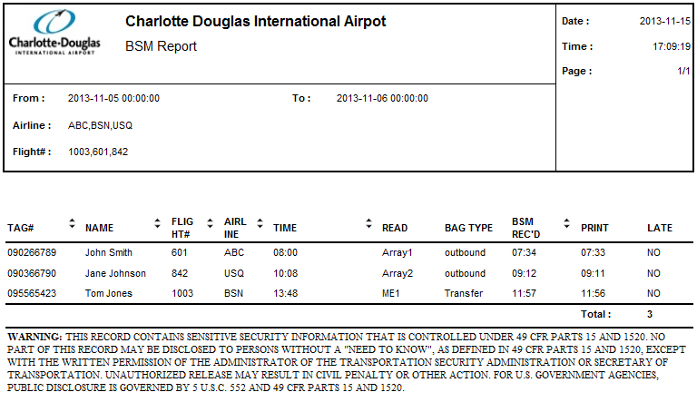

Figure ‑: BSM Report Sample

## Bag Data Report

**General Information:**

|  |  |
| --- | --- |
| **Report Title** | Bag Data Report |
| **Purpose** | Provides information of the bags. |

**Report Boundaries:**

|  |  |  |
| --- | --- | --- |
| **No.** | **Parameter Name** | **Description** |
| 1 | From | The duration from which the data will be retrieved for the report. |
| 2 | To | The duration to which the data will be retrieved for the report. |

**Report Fields:**

|  |  |  |  |
| --- | --- | --- | --- |
| **No.** | **Fields Name** | **Data Type** | **Description** |
| 1 | BHS Tracking ID | Text | The bag GID. |
| 2 | Bag Type | Text | The bag type (OOG or in-spec). |
| 3 | EDS Serial Number | Text | Screened by EDS Machine with machine Serial Number. |
| 4 | Time Stamp  (EDS or OOG) | Text | Time Stamped when entering into the EDS machine or time Stamped when OOG bags are identified. |
| 5 | LeveL 1 Status | Text | Level 1 Screening Status. |
| 6 | Level 1 Time Stamp | Text | Time Stamped at Level 1 Screening Decision. |
| 7 | Level 2 Status | Text | Level 2 Screening Status. |
| 8 | Level 2 Time Stamp | Text | Time Stamped at Level 2 Screening Decision. Note: Not all EDS machines have the capability to time stamp at both Level 1 and decisions - Confirm with EDS OEM. |
| 9 | CBRA Time Delivered | Text | Time Stamped when delivered to CBRA Unload Conveyors. |
| 10 | CBRA Time Removed | Text | Time Stamped when removed from CBRA Unload Conveyors. |
| 11 | CBRA ETD Station# | Text | CBRA ETD Screening Station Number. |

**Report Sample:**

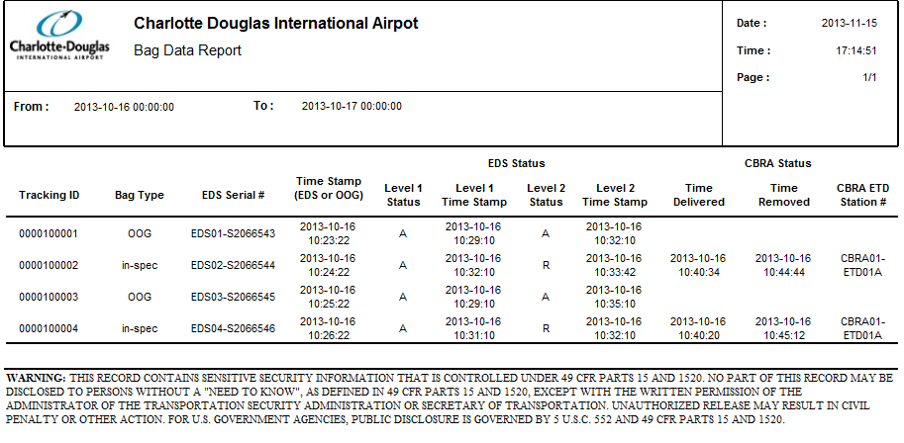

Figure ‑: Bag Data Sample

## EDS Statistics Report

**General Information:**

|  |  |
| --- | --- |
| **Report Title** | EDS Statistics Report |
| **Purpose** | Printout of EDS statistics information for each EDS machine |

**Report Boundaries:**

|  |  |  |
| --- | --- | --- |
| **No.** | **Parameter Name** | **Description** |
| 1 | From | The duration from which the data will be retrieved for the report. |
| 2 | To | The duration to which the data will be retrieved for the report. |

**Report Fields:**

|  |  |  |  |
| --- | --- | --- | --- |
| **No.** | **Fields Name** | **Data Type** | **Description** |
| 1 | EDS ID | Text | The identification of EDS machine. |
| 2 | Operation Start Time | Text | Start time of operation. |
| 3 | Operation End Time | Text | End time of operation. |
| 4 | Operation Duration | Text | EDS Machine operational duration. |
| 5 | EDS Machine Faults | Numeric | The description of EDS Machine faults (if it is known). |
| 6 | Fault Start Time | Text | Start time of fault. |
| 7 | Fault End Time | Text | End time of fault. |
| 8 | Bags Alarmed | Numeric | Count of Bags Alarmed by Specific EDS Machine. |
| 9 | Bags Cleared | Numeric | Count of Bags Cleared by Specific EDS Machine. |

**Report Sample:**

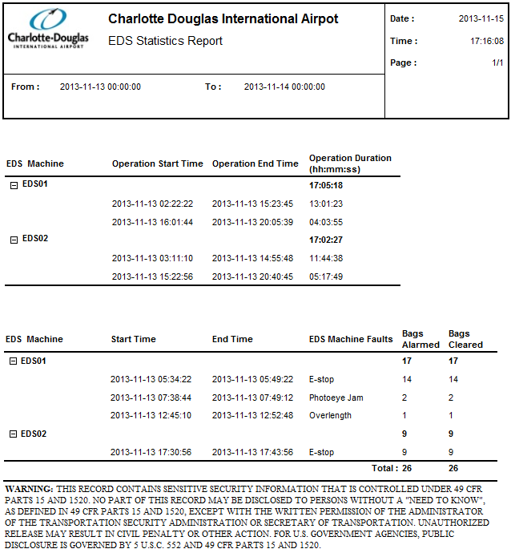

Figure ‑: EDS Statistics Report Sample

## Critical Tracking PEC

**General Information:**

|  |  |
| --- | --- |
| **Report Title** | Critical Tracking PEC Report |
| **Purpose** | Provides critical tracking information about each bag on some important subsystems. |

**Report Boundaries:**

|  |  |  |
| --- | --- | --- |
| **No.** | **Parameter Name** | **Description** |
| 1 | From | The duration from which the data will be retrieved for the report. |
| 2 | To | The duration to which the data will be retrieved for the report. |

**Report Fields 1:**

|  |  |  |  |
| --- | --- | --- | --- |
| **No.** | **Fields Name** | **Data Type** | **Description** |
| 1 | Screening Status | Text | The screening type of EDS machine |
| 2 | Number of Bags | Numeric | The IATA License Plate |

**Report Fields 2:**

|  |  |  |  |
| --- | --- | --- | --- |
| **No.** | **Fields Name** | **Data Type** | **Description** |
| 1 | IATA/Pseudo# | Text | The IATA License Plate or Pseudo number of bags |
| 2 | EDS ID | Text | The identification of EDS machine |
| 3 | Action | Text | The action made by subsystem for each bag |
| 4 | Time | Date Time | The date time of each action |
| 5 | EDS Status | Text | The screening result of EDS for each bag |

**Report Sample:**

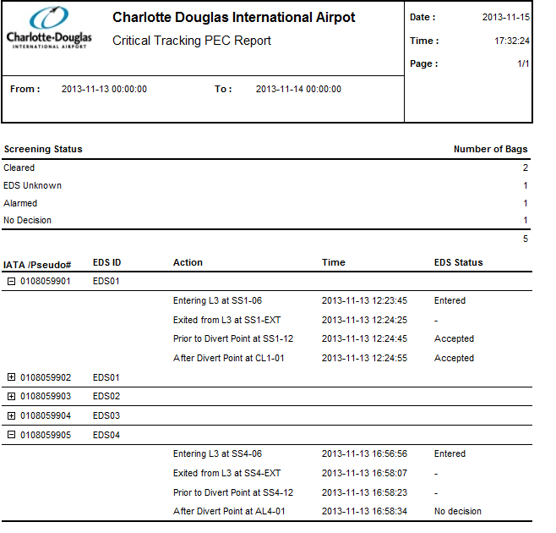 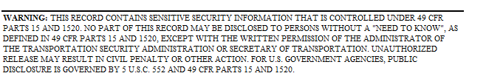

Figure ‑: Critical Tracking PEC Report Sample

## PEC Tracking Statistics

**General Information:**

|  |  |
| --- | --- |
| **Report Title** | PEC Tracking Statistics Report |
| **Purpose** | Provide the statistics information for each PEC |

**Report Boundaries:**

|  |  |  |
| --- | --- | --- |
| **No.** | **Parameter Name** | **Description** |
| 1 | From | The duration from which the data will be retrieved for the report. |
| 2 | To | The duration to which the data will be retrieved for the report. |

**Report Fields:**

|  |  |  |  |
| --- | --- | --- | --- |
| **No.** | **Fields Name** | **Data Type** | **Description** |
| 1 | Photo Cell ID | Text | Photo Cell ID |
| 2 | Bags Seen | Numeric | Total number of bags seen at each PEC. |
| 3 | Missing Bags | Numeric | Total number of missing bags at each PEC. |
| 4 | Unknown Bags | Numeric | Total number of unknown bags at each PEC. |
| 5 | Jams | Numeric | Total number of jams at each PEC. |
| 6 | Missing Bags Jams | Numeric | Total number of missing bag jams at each PEC. |

**Report Sample:**

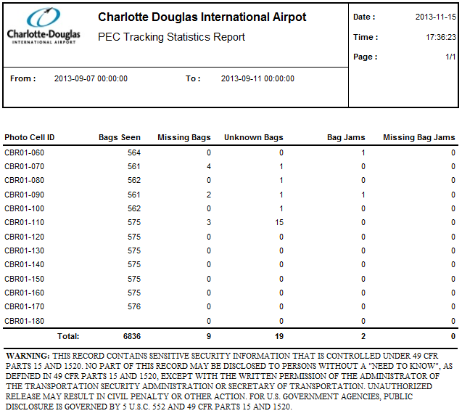

Figure ‑: PEC Tracking Statistics Report Sample

## Baggage Dimensioner Statistics Report

**General Information:**

|  |  |
| --- | --- |
| **Report Title** | Baggage Dimensioning Statistics Report |
| **Purpose** | Provides information for the Baggage Dimension Device. |

**Report Boundaries:**

|  |  |  |
| --- | --- | --- |
| **No.** | **Parameter Name** | **Description** |
| 1 | From | The duration from which the data will be retrieved for the report. |
| 2 | To | The duration to which the data will be retrieved for the report. |

**Report Fields:**

|  |  |  |  |
| --- | --- | --- | --- |
| **No.** | **Fields Name** | **Data Type** | **Description** |
| **1** | **BDD Statistics** | **-** | **-** |
| 1.1 | BDD ID | Text | The Baggage Dimension Device identification. |
| 1.2 | Out of Gauge | Numeric | The total count of out of gauge bag. |
| 1.3 | Normal | Numeric | The total count of normal size bag. |
| 1.4 | Not Dimensioned | Numeric | The total count of bag not dimensioned as PLC did not received any dimension data for the baggage. |
| 1.5 | Count | Numeric | The total counts of bags passed through BDD. |
| **2** | **BDD Fault** | **-** | **-** |
| 2.1 | BDD ID | Text | The Baggage Dimension Device identification. |
| 2.2 | Start Time | Text | The start time for the BDD fault occurred. |
| 2.3 | End Time | Text | The end time for the BDD fault occurred. If the fault is still not recovered, this field will be empty. |
| 2.4 | Duration (HH:mm:ss) | Text | The duration of the BDD fault occurrence specified in HH:mm:ss format. If the fault is still not recovered, this field will be empty.  *Note: HH = hours (24 hours format), mm = minutes, ss = seconds* |
| 2.5 | Count | Numeric | The total counts of BDD fault occurred. |

**Report Sample:**

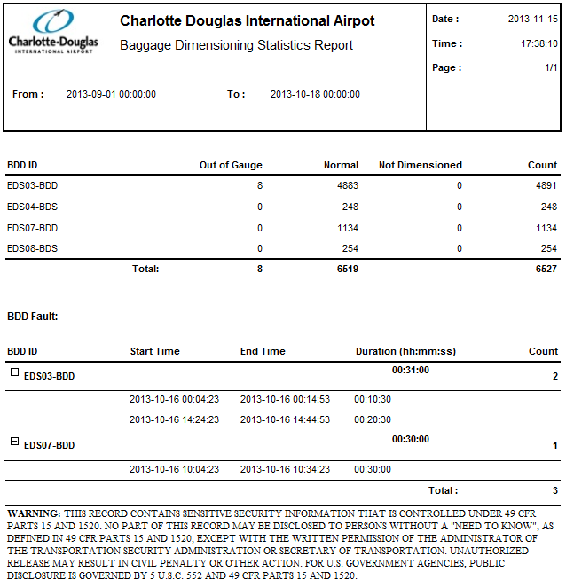

Figure ‑: Baggage Dimensioner Statistics Report Sample

## CBRA Area Statistics Report

**General Information:**

|  |  |
| --- | --- |
| **Report Title** | CBRA Area Statistics Report |
| **Purpose** | Provides statistics information for each CBRA |

**Report Boundaries:**

|  |  |  |
| --- | --- | --- |
| **No.** | **Parameter Name** | **Description** |
| 1 | From | The duration from which the data will be retrieved for the report. |
| 2 | To | The duration to which the data will be retrieved for the report. |

**Report Fields:**

|  |  |  |  |
| --- | --- | --- | --- |
| **No.** | **Fields Name** | **Data Type** | **Description** |
| 1 | CBRA ID | Text | The identification of CBRA |
| 2 | Inspection Table ID | Text | The identification of inspection table |
| 2 | Bags Received | Numeric | Total Number of Bags Received in CBRA. |
| 3 | Bags Cleared | Numeric | Total Number of Bags Cleared by CBRA. |
| 4 | Bags Inspection Table | Numeric | Total Number of Bags per CBRA Baggage Inspection Table. |

**Report Sample:**

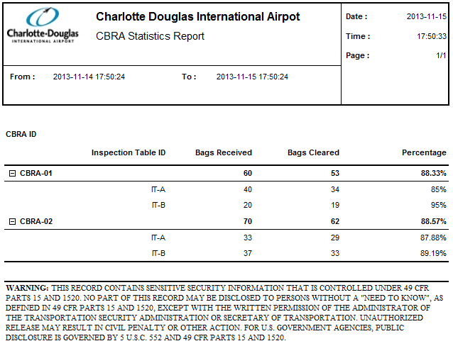

Figure ‑: CBRA Area Statistics Report Sample

## Time In System Statistics Report

**General Information:**

|  |  |
| --- | --- |
| **Report Title** | Time in System Statistic |
| **Purpose** | Provides information on the transport time for the baggage processed from ATR to exit of EDS area. |

**Report Boundaries:**

|  |  |  |
| --- | --- | --- |
| **No.** | **Parameter Name** | **Description** |
| 1 | From | The duration from which the data will be retrieved for the report. |
| 2 | To | The duration to which the data will be retrieved for the report. |
| 3 | Interval | The distribution interval in term of minutes to be used.  Interval value: 1 Minute to 24hours. |

**Report Fields:**

|  |  |  |  |
| --- | --- | --- | --- |
| **No.** | **Fields Name** | **Data Type** | **Description** |
| 1 | Minimum | Text | Minimum Time Bag was in System. |
| 2 | Maxnium | Text | Maximum Time Bag was in System. |
| 3 | Average Time in System | Text | Average Time Bag was in System. |
| 4 | Average Time in Level 1 Screening | Text | Average Time Bag was in System by Screening Level 1. |
| 5 | Average Time in Level 2 Screening | Text | Average Time Bag was in System by Screening Level 2. |

**Report Sample:**

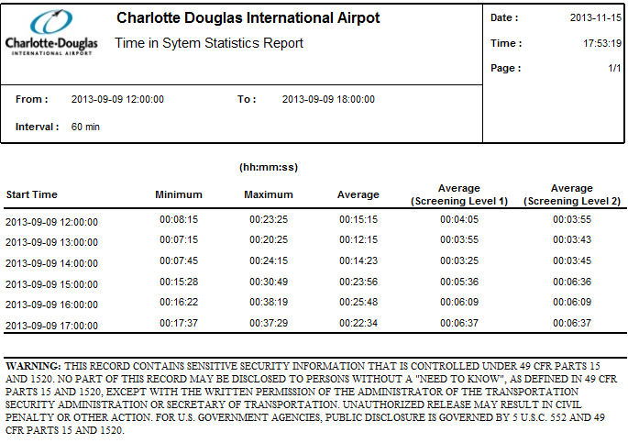

Figure ‑: Time In System Statistics Report Sample